 | RIVER VALLEY HIGH SCHOOL  YEAR 6 PRELIMINARY EXAMINATION

CANDIDATE NAME
CLASS | 6
CENTRE NUMBER | S |  |  |  |  |  | INDEX NUMBER

H1 CHEMISTRY |  |  | 8872/02
Paper 2 |  |  | 21 September 2010  2 hours
Candidates answer Section A on the Question Paper.
Additional Materials: | Data Booklet
READ THESE INSTRUCTIONS FIRST

Write your name, class, Centre number and index number on all the work you hand in.
Write in dark blue or black pen on both sides of the paper.
You may use a soft pencil for any diagrams, graphs or rough working.
Do not use staples, paper clips, highlighters, glue or correction fluid.

Section A
Answer all the questions.

Section B
Answer two questions on separate answer paper.

A Data Booklet is provided. Do not write anything on it.

The number of marks is given in brackets [ ] at the end of each question or part question.
At the end of the examination, fasten all your work securely together.

For Examiner’s Use
Section A
B5
B6
B7
Total
________________________________________________________________________________________________________
This document consists of 12 printed pages.
Section A

Answer all questions in this section.

1 | The Kolbe reaction is an organic reaction named after Adolph Kolbe. It is formally a decarboxylative dimerisation and proceeds by a free radical reaction mechanism.  When the salt of a monocarboxylic acid, RCOOH, is electrolysed, an alkane (R−R) is produced via the following steps.  Step 1 : RCOO⁻ → R + CO₂ + e⁻  Step 2 : 2R → R−R  Electrolysis of a mixture of salts of two mono-carboxylic acids A (RCOOH) and B (R’COOH) produces three straight-chain alkanes C, D and E, which can be separated by fractional distillation.
 | (a) | A solution containing 0.400 g of A required 19.60 cm³ of 0.100 mol dm⁻³ barium hydroxide for complete neutralisation.  Calculate the relative molecular mass of A.
 |  |  | [2]
 | (b) | A gaseous sample of 0.300 g of C occupied a volume of 84.0 cm³ at 25 °C and 1 atm.  Calculate the relative molecular mass of C.
 |  |  | [2]

 | (c) | A 1.00 g sample of D was burned in an excess of oxygen and the residual gas was passed through silica gel (to absorb the water vapour) and then bubbled through concentrated NaOH(aq). It was found that the mass of silica gel increased by 1.55 g and the NaOH(aq) bottle increased in mass by 3.03 g.
 |  | (i) | Calculate the number of moles of carbon dioxide, and of water, produced.
 |  | (ii) | Hence, calculate the C:H ratio in D.
 |  |  |  |  | [2]
 | (d) | Using your results from (a)–(c), suggest the structures of A to E.
 |  | A: |  | …………………………………………………
 |  | B: |  | …………………………………………………
 |  | C: |  | …………………………………………………
 |  | D: |  | …………………………………………………
 |  | E: |  | ………………………………………………… | [3]

 | (e) | When acid B is in the liquid state, its relative molecular mass is found to be almost twice that in the aqueous state.  With the aid of a diagram, explain this observation.
 |  | Diagram:
 |  | Explanation: | ……………………………….…………………………………….
 |  | ………………………………………………………………………………...……….
 |  | ………………………………………………………………………………...……….
 |  | ………………………………………………………………………………...……….
 |  | ………………………………………………………………………………...………. |  | [3]
 | (f) | The K_{a} values for three monocarboxylic acids are given below.  Explain the differences in the K_{a} values.
  acid | K_{a}
  CH₃COOH | 4.73
  CCl₃COOH | 0.63
  C₆H₅COOH | 4.20
 |  | ………………………………………………………………………………...……….
 |  | ………………………………………………………………………………...……….
 |  | ………………………………………………………………………………...……….
 |  | ………………………………………………………………………………...……….
 |  | ………………………………………………………………………………...……….
 |  | ………………………………………………………………………………...……….
 |  | ………………………………………………………………………………...……….
 |  | ………………………………………………………………………………...……….
 |  | ………………………………………………………………………………...………. |  | [3]
 |  | [Total: 15]

2 | (a) | Ammonia is an extremely valuable inorganic substance used in the fertiliser industry, the manufacture of explosives, and many other applications.  Ammonia is mainly produced via the Haber process:  N₂(g) + 3H₂(g)  2NH₃(g)
 |  | (i) | Write an expression for the equilibrium constant, K_{c}, for the reaction in the Haber process.
 |  |  | ……………………………………………………………………….…………
 |  | (ii) | Calculate the value of K_{c} given the following equilibrium composition in a 2 dm³ reaction vessel at 1000 K.
  substance | amount at equilibrium /mol
  nitrogen | 14.0
  hydrogen | 18.0
  ammonia | 1.6
 |  | (iii) | The reaction between nitrogen and hydrogen is slow because nitrogen is chemically inert.  Suggest why nitrogen is so unreactive.
 |  |  | ………………………………………………………………………………….
 |  |  |  | [4]

 | (b) | Ammonia can also act as a precursor for the synthesis of the cationic component of ionic liquids.  Ionic liquids are salts which exist in the liquid state at temperatures below 100 °C. There is increased interest in these ionic liquids because their physical properties (e.g. electrical conductivity, ability to dissolve inorganic or organic compounds) can be easily manipulated by varying the types of cations and anions present.  An example of an ionic liquid is tetrahexylammonium tetrafluoroborate:  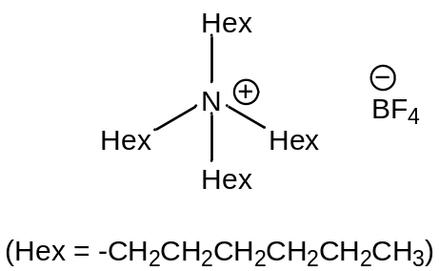
 |  | (i) | Suggest a dot-and-cross diagram to show the bonding in the tetrafluoroborate anion, BF₄⁻, and state its shape.
 |  |  | Diagram:
 |  |  | Shape: | ……………………………………………………………………..
 |  | (ii) | Explain why ionic liquids are good solvents for both polar and non-polar substances.
 |  |  | ………………………………………………………………………………….
 |  |  | ………………………………………………………………………………….
 |  |  | ………………………………………………………………………………….
 |  | (iii) | Explain why ionic liquids can conduct electricity.
 |  |  | ………………………………………………………………………………….
 |  |  |  |  |  |  | [5]
 |  | [Total: 9]

3 | The use of the Data Booklet is relevant in this question.  The oxides of elements in Period 3 of the Periodic Table show different properties.
 | (a) | Explain, in terms of structures and bonding, why
 |  | (i) | the melting point of SiO₂ is much higher than that of SO₂,
 |  |  | ………………………………………………………………………………….
 |  |  | ………………………………………………………………………………….
 |  |  | ………………………………………………………………………………….
 |  |  | ………………………………………………………………………………….
 |  | (ii) | the melting point of MgO is higher than that of Na₂O.
 |  |  | ………………………………………………………………………………….
 |  |  | ………………………………………………………………………………….
 |  |  | ………………………………………………………………………………….
 |  |  | ………………………………………………………………………………….
 |  |  |  |  | [4]
 | (b) | Write equations for the reactions when Na₂O and P₄O₁₀ are separately added to water. State the pH of the resulting solutions formed.
 |  | Na₂O
 |  | Equation: |  | …………………………………………………………………………
 |  | pH: | ………
 |  | P₄O₁₀
 |  | Equation: |  | …………………………………………………………………………
 |  | pH: | ……… |  | [3]
 | (c) | Al₂O₃ is said to be amphoteric.  Using Al₂O₃ as an example, write two equations to illustrate the term amphoteric.
 |  | …………………………………………………………………………………………
 |  | ………………………………………………………………………………………… |  |  | [2]
 |  | [Total: 9]

4 | (a) | Jasmonic acid, methyl jasmonate and jasmone are volatile natural compounds extracted from jasmine flowers.
 |  | 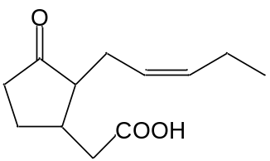jasmonic acid | 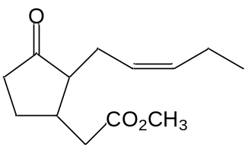methyl jasmonate | 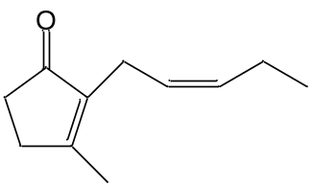jasmone
 |  | Describe, by means of simple chemical tests, how you would distinguish between the three compounds shown above.
 |  | …………………………………………………………………………………………
 |  | …………………………………………………………………………………………
 |  | …………………………………………………………………………………………
 |  | …………………………………………………………………………………………
 |  | …………………………………………………………………………………………
 |  | …………………………………………………………………………………………
 |  | …………………………………………………………………………………………
 |  | ………………………………………………………………………………………… |  |  | [4]
 | (b) | State the reagents and conditions for converting jasmonic acid to methyl jasmonate in the laboratory.
 |  | ………………………………………………………………………………………… |  |  | [1]
 | (c) | Jasmonic acid and methyl jasmonate function as volatile signaling molecules that are released when plants suffer injury.  State and explain which of the compounds you would expect to be more volatile.
 |  | …………………………………………………………………………………………
 |  | …………………………………………………………………………………………
 |  | …………………………………………………………………………………………
 |  | ………………………………………………………………………………………… |  |  | [2]
 |  | [Total: 7]

Section B

Answer two of the three questions in this section on separate answer paper.

5 | Ethanol is an increasingly important ‘bio-fuel’ as it can be produced from renewable sources as such sugar-cane and other plants.
 | (a) | Define, with the aid of an equation, the standard enthalpy change of combustion of ethanol. |  | [2]
 | (b) | 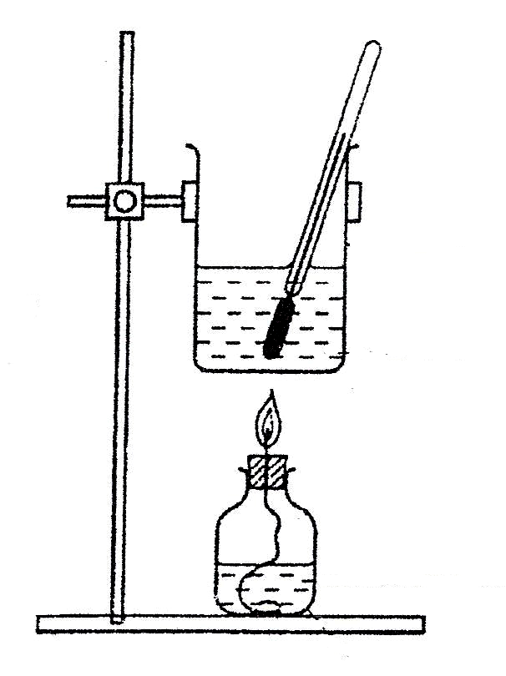  The figure below shows a diagram of a calorimeter used by a student to determine the enthalpy change of combustion of ethanol.  thermometer  small metal can  spirit lamp containing ethanol  wick  water
 |  | (i) | When 0.96 g of ethanol was combusted in a calorimeter, the energy evolved heated 100 cm³ of water from 28.0 °C to 65.3 °C.  Given that this process is only 70% efficient, use these data and values from the Data Booklet to calculate the enthalpy change of combustion of ethanol.
 |  | (ii) | Suggest a possible reason why only 70% of the heat produced from the combustion is used to warm the water.
 |  |  |  | [4]
 | (c) | An accurate value for the standard enthalpy change of combustion of ethanol is −1370 kJ mol⁻¹.  Suggest why the value calculated in (b)(i) is still less than the accurate value despite having taken into account the efficiency of heat transfer to the water. |  | [1]
 | (d) | (i) | Use the bond energies given in the Data Booklet to calculate another value for the standard enthalpy change of combustion of ethanol.
 |  | (ii) | Suggest a reason for the discrepancy between this value and the accurate value given in (c).
 |  |  |  | [3]
 | (e) | Bromoethane can be hydrolysed by aqueous sodium hydroxide to form ethanol. Results of an investigation into the kinetics of this reaction are given below.
  experiment number | [CH₃CH₂Br] /mol dm⁻³ | [NaOH(aq)] / mol dm⁻³ | relative initial rate
  1 | 0.10 | 0.20 | 1.00
  2 | 0.20 | 0.10 | 1.00
  3 | 0.30 | 0.20 | 3.00
 |  | (i) | Use the data in the table to deduce the order of reaction with respect to CH₃CH₂Br and with respect to NaOH. Hence write an overall rate equation for the reaction.
 |  | (ii) | Calculate a value for the rate constant, giving its units.
 |  | (iii) | Explain what is meant by the term activation energy.
 |  | (iv) | Describe how the activation energy is affected by the presence of a catalyst, and explain how this increases the rate of reaction.
 |  | (v) | Explain, in molecular terms, how the initial reaction rate would be affected by changing the concentration of reactants in a reaction.
 |  |  |  | [10]
 |  | [Total: 20]

6 | (a) | What do you understand by the Bronsted-Lowry theory of acids and bases? |  | [2]
 | (b) | For each of the following reactions (1) and (2):
 |  | (i) | identify the two acids and the two bases present;
 |  | (ii) | suggest, with reasons, which ion or molecule is the stronger acid, and which is the stronger base.
 |  | (1) NH₃ + H₂O  NH₄⁺ + OH⁻ K_{c} = 1.8 × 10⁻⁵ mol dm⁻³  (2) C₆H₅O⁻ + CH₃COOH  C₆H₅OH + CH₃COO⁻ K_{c} = 1.3 x 10⁶ mol dm⁻³ |  | [5]
 | (c) | (i) | The pH of a 0.1 mol dm⁻³ solution of CH₃COOH(aq) is 2.4, whereas the pH of a 0.1 mol dm⁻³ solution of HCl(aq) is 1.0.  Calculate the ratio of hydrogen ion concentrations in these two solutions.
 |  | (ii) | However, when 100 cm³ of 0.1 mol dm⁻³ CH₃COOH(aq) is reacted with an excess of zinc powder, the same volume of hydrogen (120 cm³) is evolved as when 100 cm³ of 0.1 mol dm⁻³ HCl(aq) is used.  Explain why this is so.
 |  |  |  | [5]
 | (d) | The standard enthalpy change of neutralisation for the reaction of NaOH(aq) with HCl(aq) and with CH₃COOH(aq) are −57.9 kJ mol⁻¹ and −56.1 kJ mol⁻¹ respectively.
 |  | (i) | Explain the difference in the values of the standard enthalpy change of neutralisation.
 |  | (ii) | Suggest a value for the standard enthalpy change of neutralisation for the reaction of NaOH(aq) with H₂SO₄(aq). Explain your answer.
 |  | (iii) | State and explain the effect of an increase in temperature on the pH of a solution of CH₃COOH(aq).
 |  | (iv) | The concentration of a solution of CH₃COOH(aq) can be determined accurately by titrating with a standard solution of NaOH(aq) but not a standard solution of NH₃(aq).  Explain why NH₃(aq) cannot be used and suggest a suitable indicator for the titration of CH₃COOH(aq) with NaOH(aq).
 |  |  |  | [8]
 |  | [Total: 20]

7 | (a) | Compound A has the molecular formula C₄H₈.  On heating A with acidified potassium manganate(VII), compound B, C₃H₆O₂, is formed.  B gives effervescence with both sodium metal and aqueous sodium carbonate.  A also reacts with cold alkaline potassium manganate(VII) to form compound C, C₄H₁₀O₂. Strong oxidation of C gives propanoic acid.  One mole of C reacts with two moles of phosphorus pentachloride to give compound D. A reacts with chlorine to also give D.  Deduce the structures of A, B, C and D. Explain your reasoning and write equations where appropriate to show the reactions that are occurring. | [10]
 | (b) | Compound T, C₉H₁₀O₂, is used in artificial flavourings.  When T is heated under reflux with dilute aqueous acid, U, C₇H₆O₂ and V, C₂H₆O, are produced.  U is insoluble in cold water but dissolves readily in aqueous sodium hydroxide.  On reacting V with aqueous alkaline iodine, a yellow precipitate, W, is produced.  When V is distilled with acidified potassium dichromate(VI), a liquid X is collected. X forms a silver mirror when warmed with Tollens’ reagent. X also forms an orange precipitate with 2,4-dinitrophenylhydrazine.  Deduce the structures of T, U, V, W and X and explain the chemistry of the reactions involved. | [10]
 |  | [Total: 20]

END OF PAPER

